Electronic Supporting Information
Diazepines. 2. Synthesis of 1,3-diazepines and ring contraction to cyano-pyrroles
Ales Reisinger, Paul V. Bernhardt and Curt Wentrup*
Department of Chemistry, School of Molecular and Microbial Sciences, The University of Queensland, Brisbane, Qld 4072, Australia. wentrup@uq.edu.au

Fig. S1. ¹⁵N NMR spectra of 1,2-[¹⁵N₂]-5-chlorotetrazolo[1,5-a]pyridine 30 (azide form 30A in CDCl₃) and its unlabelled analog 21A (40.56 MHz); reference: external nitromethane.
Fig. S2. ¹⁵N NMR spectra of 1-[¹⁵N]-3-cyano-2-diisopropylaminopyrrole 37 and its unlabelled analog 27 in benzene-d₆ (40.56 MHz); reference: external nitromethane.
Fig. S3. ORTEP view of compound 6T (30% ellipsoids).
Fig. S4. ORTEP view of two centrosymmetrically related 6T molecules (30% ellipsoids).
Fig. S5. ORTEP view of compound 9Tb (30% ellipsoids).
Fig. S6. ORTEP packing diagram of compound 9Tb (30% ellipsoids).
Tables S1-S4: bond lengths and angles for 6T, 9Tb, 25h, and 28.
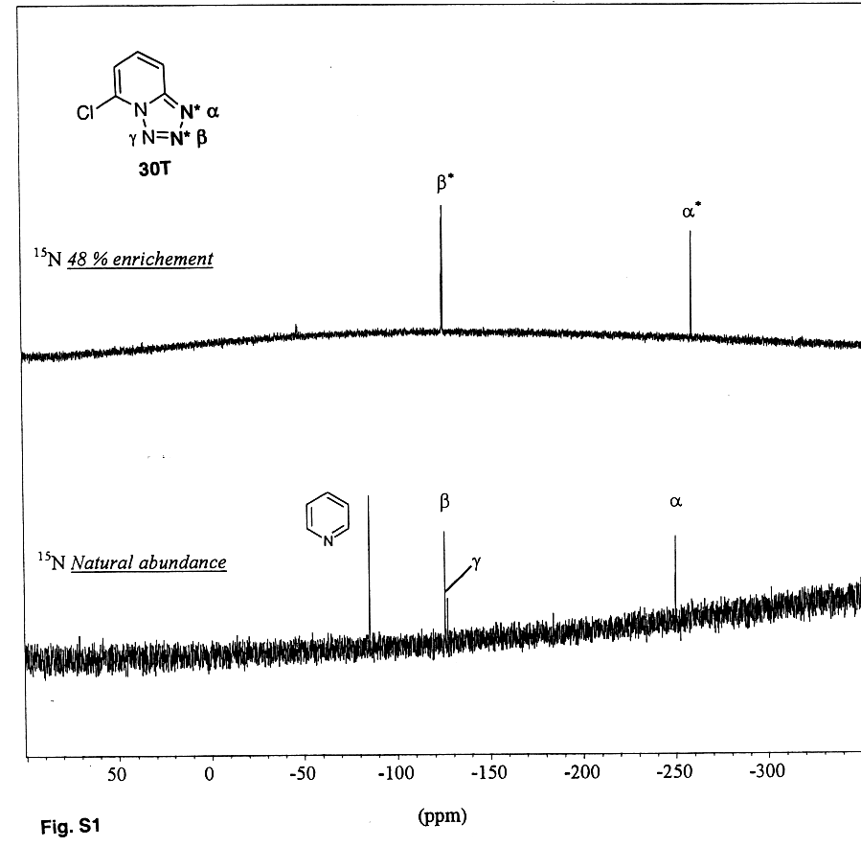
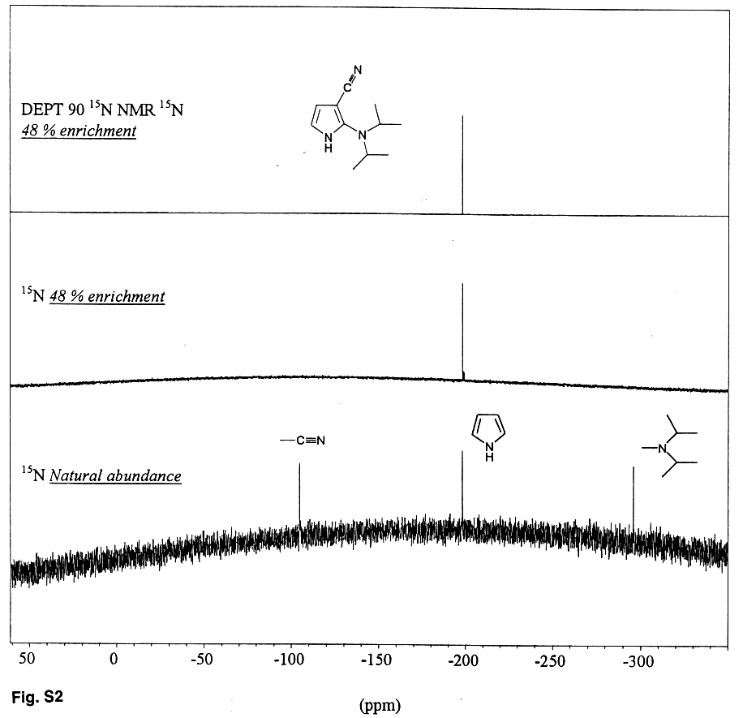
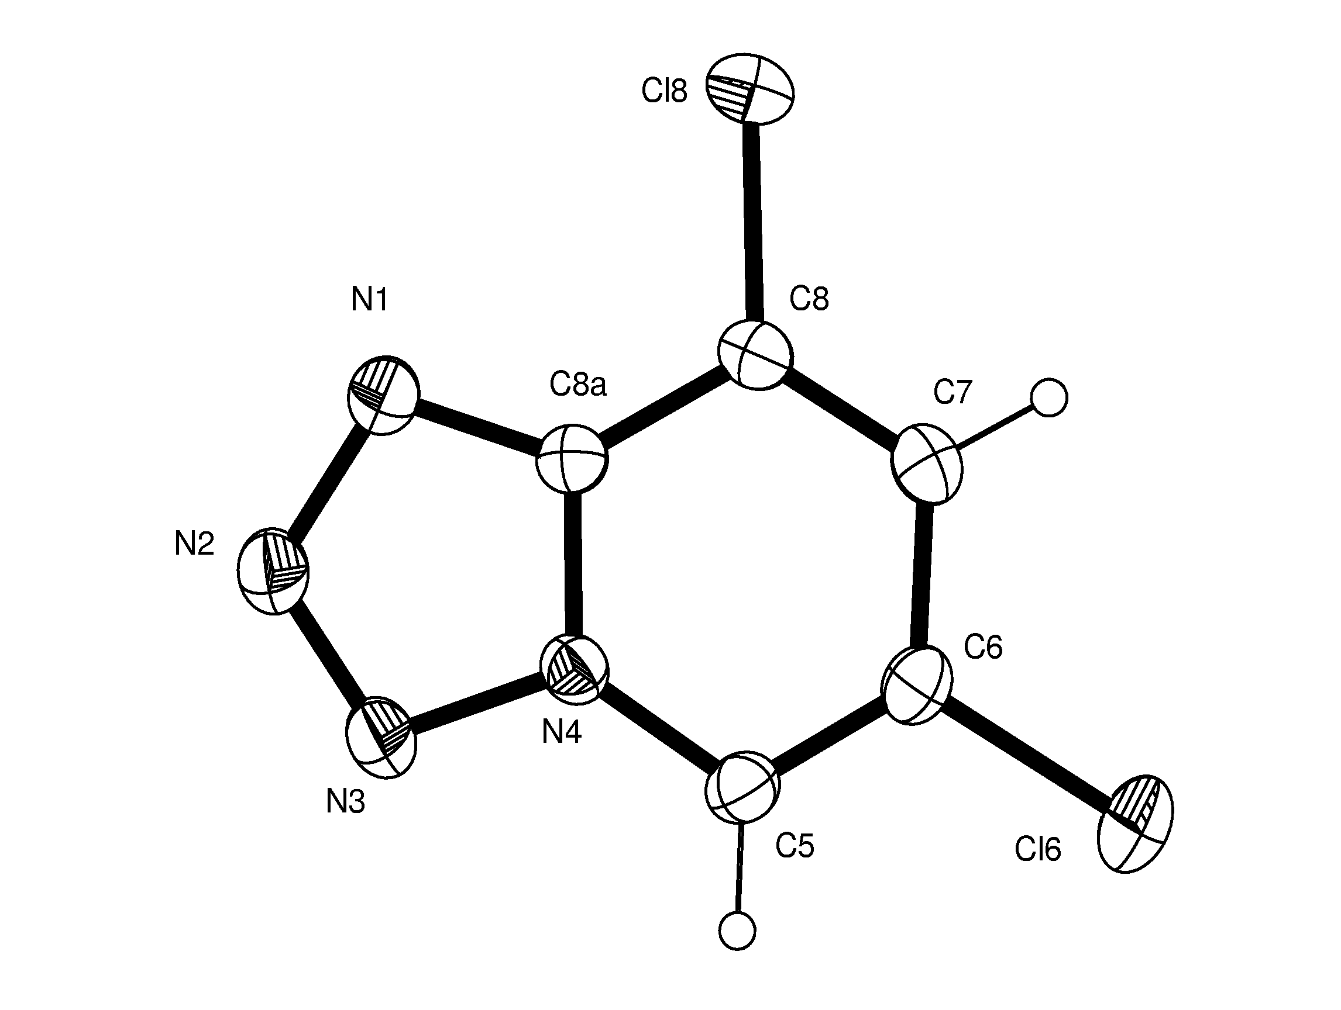

Fig. S3
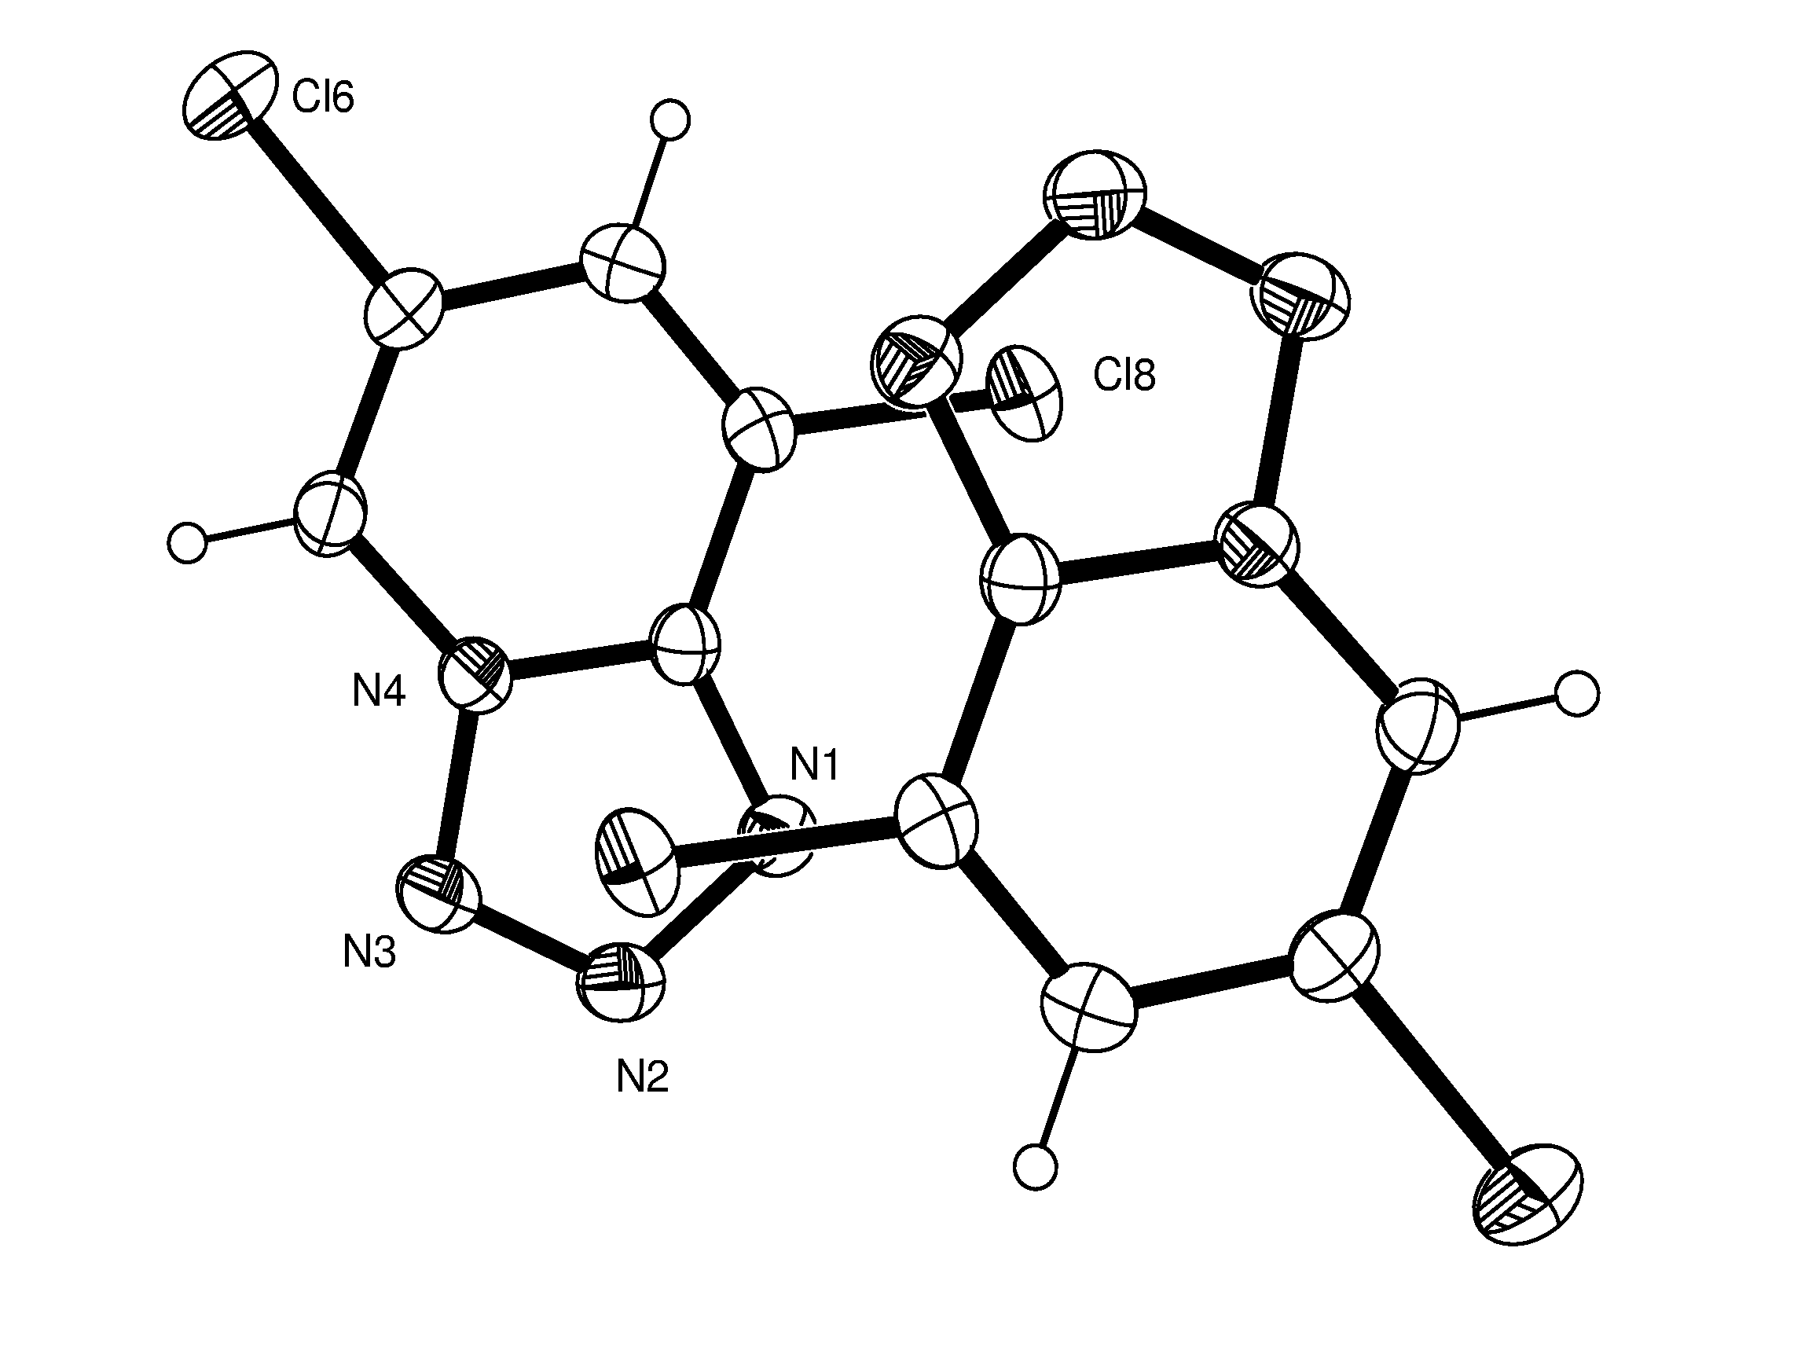
Fig. S4

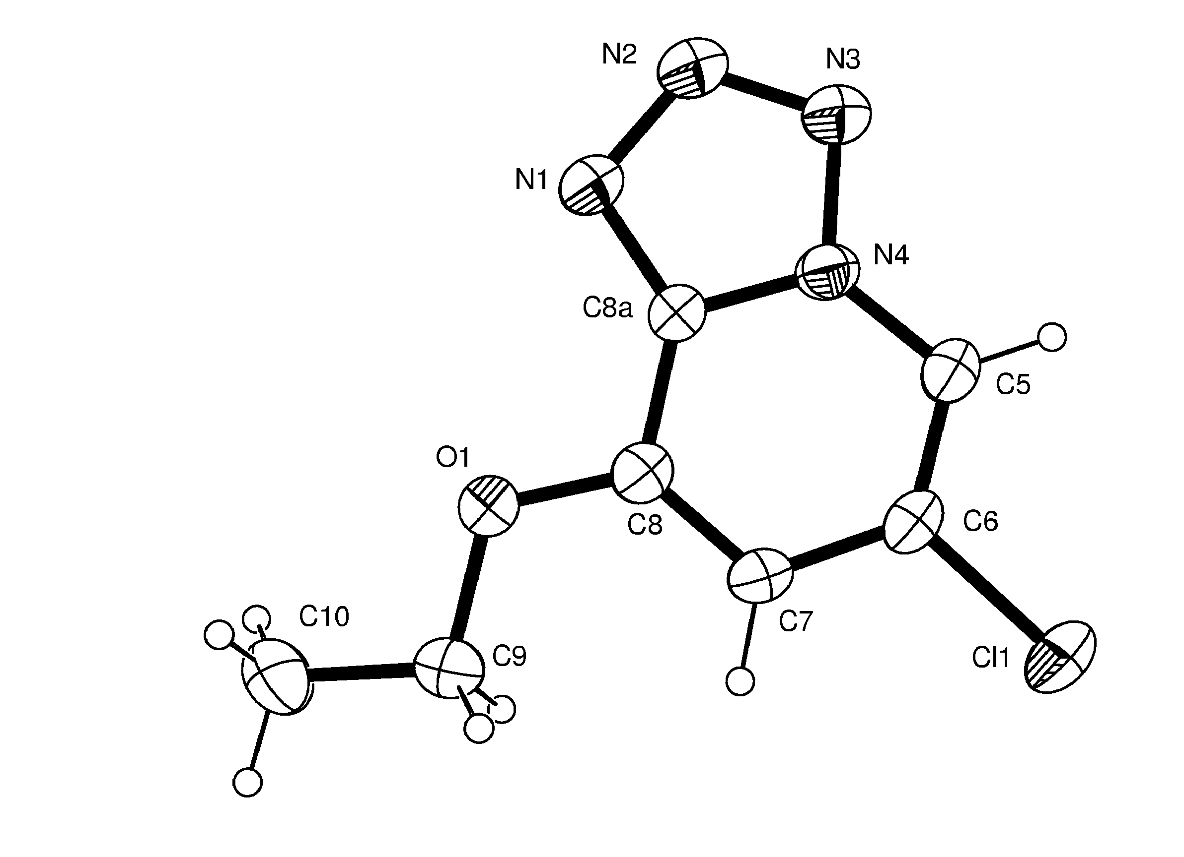
Fig. S5

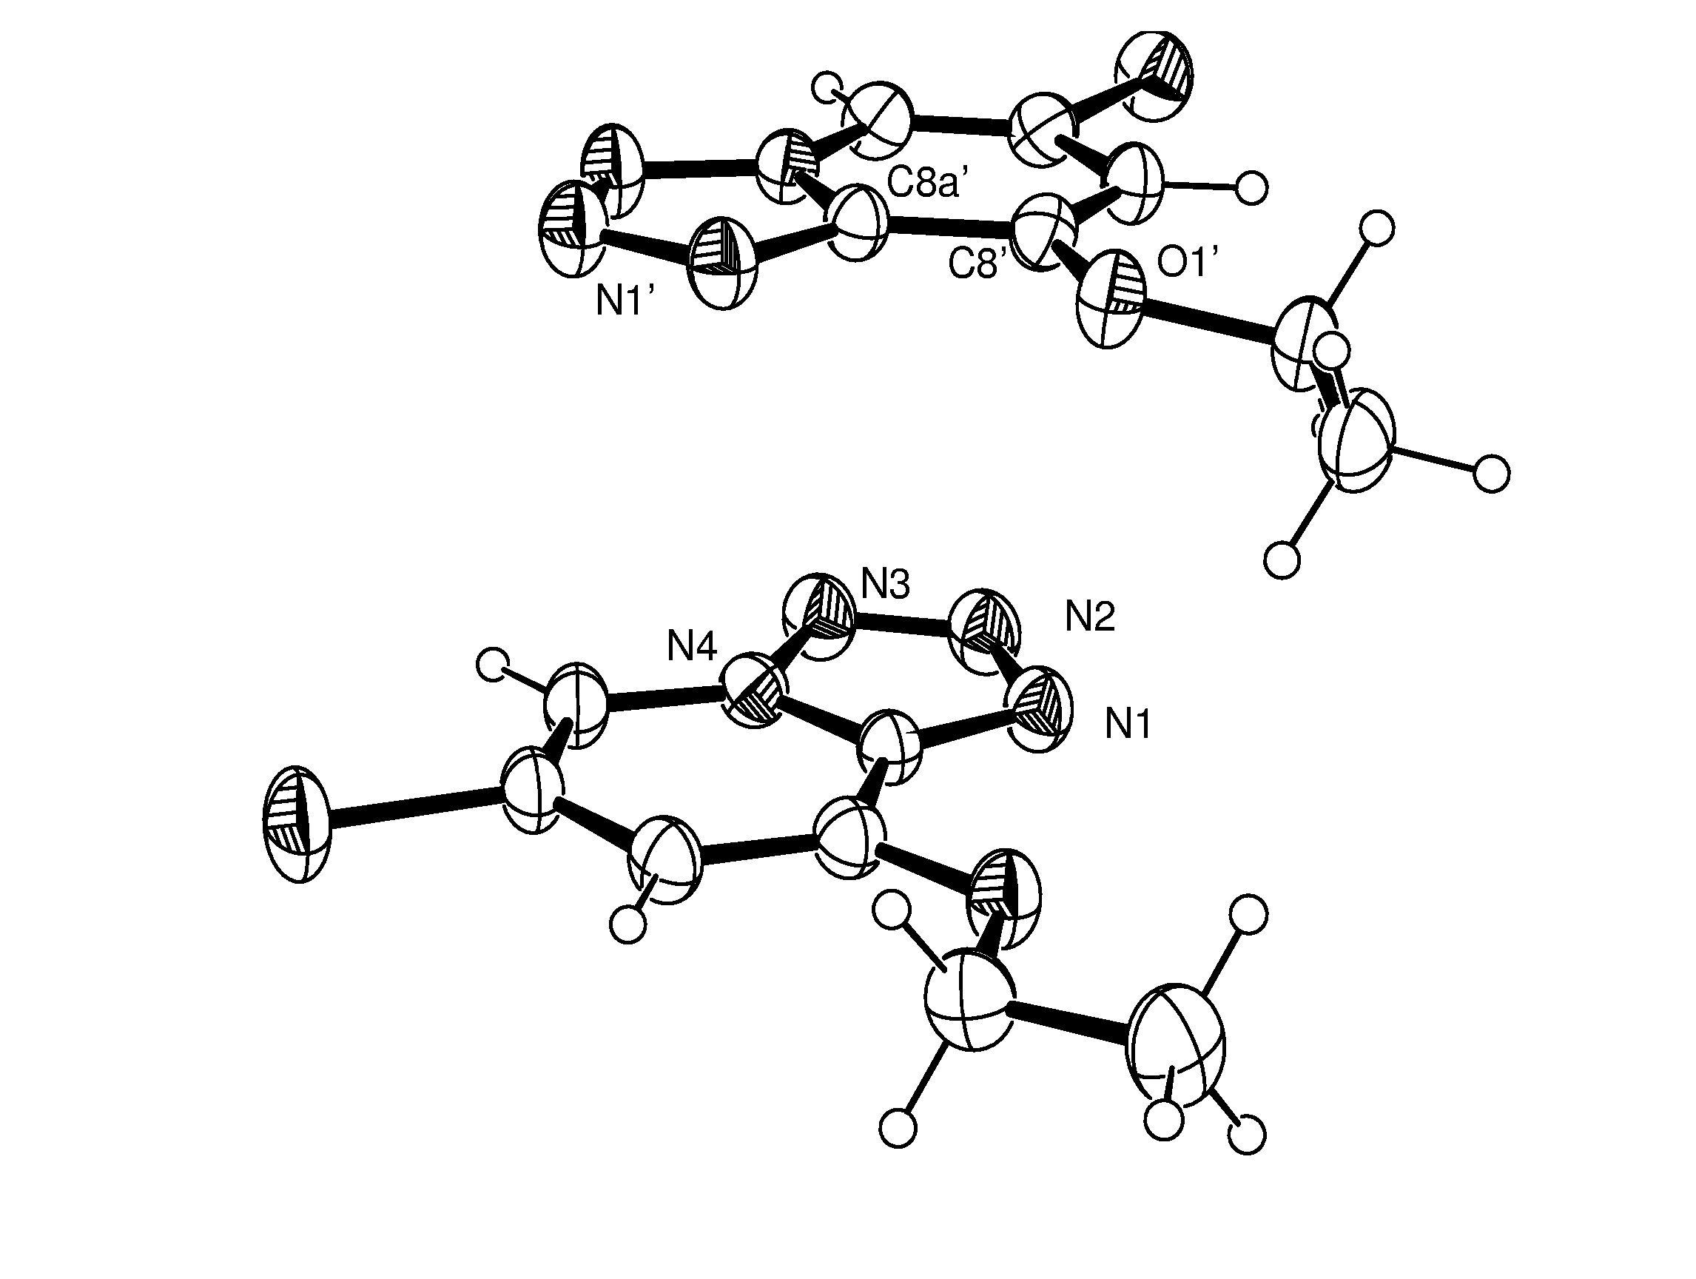
3.280(4) Å
3.301(4) Å
3.307(5) Å
3.266(5) Å

Fig. S6
Table S1. Bond lengths [Å] and angles [°] for 6,8-dichlorotetrazolo[1,5-a]pyridine, 6T, CCDC 222023.
_____________________________________________________
N(1)-C(8A) 1.331(3)
N(1)-N(2) 1.357(3)
N(2)-N(3) 1.295(3)
N(3)-N(4) 1.374(3)
N(4)-C(8A) 1.357(3)
N(4)-C(5) 1.365(3)
C(5)-C(6) 1.346(3)
C(6)-C(7) 1.426(3)
C(6)-Cl(6) 1.719(2)
C(7)-C(8) 1.349(3)
C(8)-C(8A) 1.408(3)
C(8)-Cl(8) 1.716(2)

C(8A)-N(1)-N(2) 105.22(18)
N(3)-N(2)-N(1) 112.78(18)
N(2)-N(3)-N(4) 105.28(17)
C(8A)-N(4)-C(5) 124.85(18)
C(8A)-N(4)-N(3) 108.03(17)
C(5)-N(4)-N(3) 127.11(17)
C(6)-C(5)-N(4) 116.3(2)
C(5)-C(6)-C(7) 122.2(2)
C(5)-C(6)-Cl(6) 118.97(18)
C(7)-C(6)-Cl(6) 118.85(17)
C(8)-C(7)-C(6) 119.1(2)
C(7)-C(8)-C(8A) 119.6(2)
C(7)-C(8)-Cl(8) 123.05(18)
C(8A)-C(8)-Cl(8) 117.31(17)
N(1)-C(8A)-N(4) 108.70(18)
N(1)-C(8A)-C(8) 133.4(2)
N(4)-C(8A)-C(8) 117.93(19)
_____________________________________________________________
Table S2. Bond lengths [Å] and angles [°] for 6-chloro-8-ethoxytetrazolo[1,5-a]pyridine 9Tb, CCDC 218060
_____________________________________________________
N(1)-C(8A) 1.336(4)
N(1)-N(2) 1.342(4)
N(2)-N(3) 1.309(4)
N(3)-N(4) 1.364(4)
N(4)-C(8A) 1.351(4)
N(4)-C(5) 1.374(4)
O(1)-C(8) 1.355(4)
O(1)-C(9) 1.445(4)
Cl(1)-C(6) 1.732(3)
C(5)-C(6) 1.347(5)
C(6)-C(7) 1.406(5)
C(7)-C(8) 1.359(4)
C(8)-C(8A) 1.416(5)
C(9)-C(10) 1.500(5)
N(1')-C(8A') 1.335(4)
N(1')-N(2') 1.351(4)
N(2')-N(3') 1.301(4)
N(3')-N(4') 1.365(4)
N(4')-C(8A') 1.355(4)
N(4')-C(5') 1.368(4)
C(5')-C(6') 1.341(5)
C(6')-C(7') 1.408(5)
C(6')-Cl(1') 1.722(4)
C(7')-C(8') 1.368(5)
C(8')-O(1') 1.345(4)
C(8')-C(8A') 1.419(4)
C(9')-O(1') 1.445(4)
C(9')-C(10') 1.483(5)

C(8A)-N(1)-N(2) 105.2(3)
N(3)-N(2)-N(1) 113.0(3)
N(2)-N(3)-N(4) 104.6(3)
C(8A)-N(4)-N(3) 108.7(3)
C(8A)-N(4)-C(5) 125.8(3)
N(3)-N(4)-C(5) 125.5(3)
C(8)-O(1)-C(9) 116.1(3)
C(6)-C(5)-N(4) 114.6(3)
C(5)-C(6)-C(7) 123.7(3)
C(5)-C(6)-Cl(1) 118.5(3)
C(7)-C(6)-Cl(1) 117.8(3)
C(8)-C(7)-C(6) 119.4(3)
O(1)-C(8)-C(7) 126.6(3)
O(1)-C(8)-C(8A) 114.7(3)
C(7)-C(8)-C(8A) 118.7(3)
N(1)-C(8A)-N(4) 108.4(3)
N(1)-C(8A)-C(8) 133.7(3)
N(4)-C(8A)-C(8) 117.9(3)
O(1)-C(9)-C(10) 107.1(3)
C(8A')-N(1')-N(2') 105.5(3)
N(3')-N(2')-N(1') 112.3(3)
N(2')-N(3')-N(4') 105.6(3)
C(8A')-N(4')-N(3') 108.1(3)
C(8A')-N(4')-C(5') 124.9(3)
N(3')-N(4')-C(5') 127.0(3)
C(6')-C(5')-N(4') 115.8(3)
C(5')-C(6')-C(7') 123.0(3)
C(5')-C(6')-Cl(1') 119.1(3)
C(7')-C(6')-Cl(1') 117.8(3)
C(8')-C(7')-C(6') 119.9(3)
O(1')-C(8')-C(7') 127.9(3)
O(1')-C(8')-C(8A') 114.4(3)
C(7')-C(8')-C(8A') 117.6(3)
N(1')-C(8A')-N(4') 108.5(3)
N(1')-C(8A')-C(8') 132.8(3)
N(4')-C(8A')-C(8') 118.7(3)
O(1')-C(9')-C(10') 107.2(3)
C(8')-O(1')-C(9') 116.8(3)
_____________________________________________________________

Table S3. Bond lengths [Å] and angles [°] for 4-Dimethylamino-2-isopropoxy-5H-1,3-diazepine 25h, CCDC 218061.
_____________________________________________________
N(1)-C(2) 1.289(2)
N(1)-C(7) 1.387(2)
C(2)-O(8) 1.3587(19)
C(2)-N(3) 1.361(2)
N(3)-C(4) 1.308(2)
C(4)-N(12) 1.340(2)
C(4)-C(5) 1.500(2)
C(5)-C(6) 1.490(3)
C(6)-C(7) 1.325(3)
O(8)-C(9) 1.4500(18)
C(9)-C(11) 1.503(2)
C(9)-C(10) 1.503(2)
N(12)-C(14) 1.453(2)
N(12)-C(13) 1.454(2)

C(2)-N(1)-C(7) 120.27(15)
N(1)-C(2)-O(8) 118.67(14)
N(1)-C(2)-N(3) 131.96(15)
O(8)-C(2)-N(3) 108.83(13)
C(4)-N(3)-C(2) 120.88(14)
N(3)-C(4)-N(12) 119.05(15)
N(3)-C(4)-C(5) 119.88(15)
N(12)-C(4)-C(5) 121.06(15)
C(6)-C(5)-C(4) 105.88(14)
C(7)-C(6)-C(5) 119.83(16)
C(6)-C(7)-N(1) 126.40(17)
C(2)-O(8)-C(9) 119.30(12)
O(8)-C(9)-C(11) 110.46(14)
O(8)-C(9)-C(10) 105.32(13)
C(11)-C(9)-C(10) 111.80(16)
C(4)-N(12)-C(14) 124.85(15)
C(4)-N(12)-C(13) 120.32(14)
C(14)-N(12)-C(13) 114.82(15)

Table S4. Bond lengths [Å] and angles [°] for 3,3’-dicyano-2,2’diisopropyldimethyldipyrrolylmethane 28, CCDC 218062
_____________________________________________________
N(1A)-C(2A) 1.360(3)
N(1A)-C(5A) 1.370(3)
N(2A)-C(2A) 1.394(3)
N(2A)-C(9A1) 1.409(5)
N(2A)-C(9A2) 1.453(7)
N(2A)-C(6A) 1.467(3)
N(12A)-C(12A) 1.141(3)
C(2A)-C(3A) 1.383(3)
C(3A)-C(4A) 1.414(3)
C(3A)-C(12A) 1.424(3)
C(4A)-C(5A) 1.360(3)
C(5A)-C(13) 1.512(3)
C(6A)-C(8A) 1.507(4)
C(6A)-C(7A) 1.525(4)
C(9A1)-C(11A) 1.537(5)
C(9A1)-C(10A) 1.562(5)
C(9A2)-C(10A) 1.514(7)
C(9A2)-C(11A) 1.547(7)
N(1B)-C(5B) 1.367(3)
N(1B)-C(2B) 1.369(3)
N(2B)-C(2B) 1.391(3)
N(2B)-C(9B1) 1.419(5)
N(2B)-C(9B2) 1.452(7)
N(2B)-C(6B) 1.465(4)
N(12B)-C(12B) 1.141(3)
C(2B)-C(3B) 1.379(3)
C(3B)-C(4B) 1.414(3)
C(3B)-C(12B) 1.424(3)
C(4B)-C(5B) 1.363(3)
C(5B)-C(13) 1.510(3)
C(6B)-C(8B2) 1.474(9)
C(6B)-C(7B1) 1.508(9)
C(6B)-C(7B2) 1.559(8)
C(6B)-C(8B1) 1.580(7)
C(9B1)-C(11B) 1.535(5)
C(9B1)-C(10B) 1.540(6)
C(9B2)-C(10B) 1.511(8)
C(9B2)-C(11B) 1.551(8)
C(13)-C(14) 1.534(4)
C(13)-C(15) 1.542(4)

C(2A)-N(1A)-C(5A) 111.33(17)
C(2A)-N(2A)-C(9A1) 116.5(2)
C(2A)-N(2A)-C(9A2) 119.7(3)
C(9A1)-N(2A)-C(9A2) 40.7(3)
C(2A)-N(2A)-C(6A) 116.1(2)
C(9A1)-N(2A)-C(6A) 121.5(2)
C(9A2)-N(2A)-C(6A) 121.1(3)
N(1A)-C(2A)-C(3A) 106.02(19)
N(1A)-C(2A)-N(2A) 121.32(19)
C(3A)-C(2A)-N(2A) 132.6(2)
C(2A)-C(3A)-C(4A) 107.94(18)
C(2A)-C(3A)-C(12A) 126.7(2)
C(4A)-C(3A)-C(12A) 125.34(19)
C(5A)-C(4A)-C(3A) 107.71(19)
C(4A)-C(5A)-N(1A) 106.99(19)
C(4A)-C(5A)-C(13) 130.9(2)
N(1A)-C(5A)-C(13) 122.02(19)
N(2A)-C(6A)-C(8A) 111.5(2)
N(2A)-C(6A)-C(7A) 113.1(2)
C(8A)-C(6A)-C(7A) 111.0(3)
N(2A)-C(9A1)-C(11A) 112.8(3)
N(2A)-C(9A1)-C(10A) 110.1(3)
C(11A)-C(9A1)-C(10A) 106.2(3)
N(2A)-C(9A2)-C(10A) 110.5(5)
N(2A)-C(9A2)-C(11A) 109.8(5)
C(10A)-C(9A2)-C(11A) 108.1(5)
C(9A2)-C(10A)-C(9A1) 37.8(3)
C(9A1)-C(11A)-C(9A2) 37.7(3)
N(12A)-C(12A)-C(3A) 177.9(3)
C(5B)-N(1B)-C(2B) 111.41(18)
C(2B)-N(2B)-C(9B1) 118.9(2)
C(2B)-N(2B)-C(9B2) 114.3(3)
C(9B1)-N(2B)-C(9B2) 41.1(3)
C(2B)-N(2B)-C(6B) 117.2(2)
C(9B1)-N(2B)-C(6B) 117.2(3)
C(9B2)-N(2B)-C(6B) 126.1(3)
N(1B)-C(2B)-C(3B) 105.6(2)
N(1B)-C(2B)-N(2B) 123.3(2)
C(3B)-C(2B)-N(2B) 131.0(2)
C(2B)-C(3B)-C(4B) 108.43(19)
C(2B)-C(3B)-C(12B) 126.1(2)
C(4B)-C(3B)-C(12B) 125.5(2)
C(5B)-C(4B)-C(3B) 107.5(2)
C(4B)-C(5B)-N(1B) 107.0(2)
C(4B)-C(5B)-C(13) 130.8(2)
N(1B)-C(5B)-C(13) 122.05(19)
N(2B)-C(6B)-C(8B2) 112.7(4)
N(2B)-C(6B)-C(7B1) 117.5(4)
C(8B2)-C(6B)-C(7B1) 74.2(5)
N(2B)-C(6B)-C(7B2) 104.2(4)
C(8B2)-C(6B)-C(7B2) 111.8(5)
C(7B1)-C(6B)-C(7B2) 37.8(4)
N(2B)-C(6B)-C(8B1) 110.3(3)
C(8B2)-C(6B)-C(8B1) 34.1(4)
C(7B1)-C(6B)-C(8B1) 104.8(5)
C(7B2)-C(6B)-C(8B1) 139.3(4)
N(2B)-C(9B1)-C(11B) 112.1(3)
N(2B)-C(9B1)-C(10B) 110.6(3)
C(11B)-C(9B1)-C(10B) 106.1(3)
N(2B)-C(9B2)-C(10B) 110.5(5)
N(2B)-C(9B2)-C(11B) 109.5(5)
C(10B)-C(9B2)-C(11B) 106.8(5)
C(9B2)-C(10B)-C(9B1) 38.6(3)
C(9B1)-C(11B)-C(9B2) 38.1(3)
N(12B)-C(12B)-C(3B) 177.8(3)
C(5B)-C(13)-C(5A) 111.41(19)
C(5B)-C(13)-C(14) 108.9(2)
C(5A)-C(13)-C(14) 109.4(2)
C(5B)-C(13)-C(15) 109.0(2)
C(5A)-C(13)-C(15) 108.2(2)
C(14)-C(13)-C(15) 109.9(2)
_____________________________________________________________

